Course Name | ITD 2343 – Object Oriented Programming with C#
Instructor | Mark L. Pranger
Student Name | Lauren Lashley
Due date | March 4, 2026
Grade | <grade earned here>
Grading Comments | <instructor comments here>

Week 8 – Programming Lab

Screenshot 1:
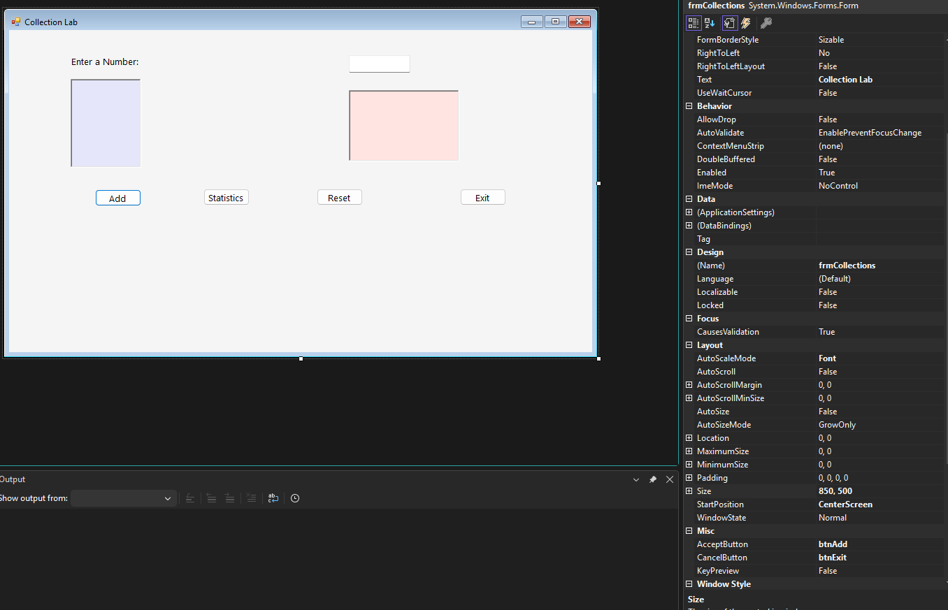

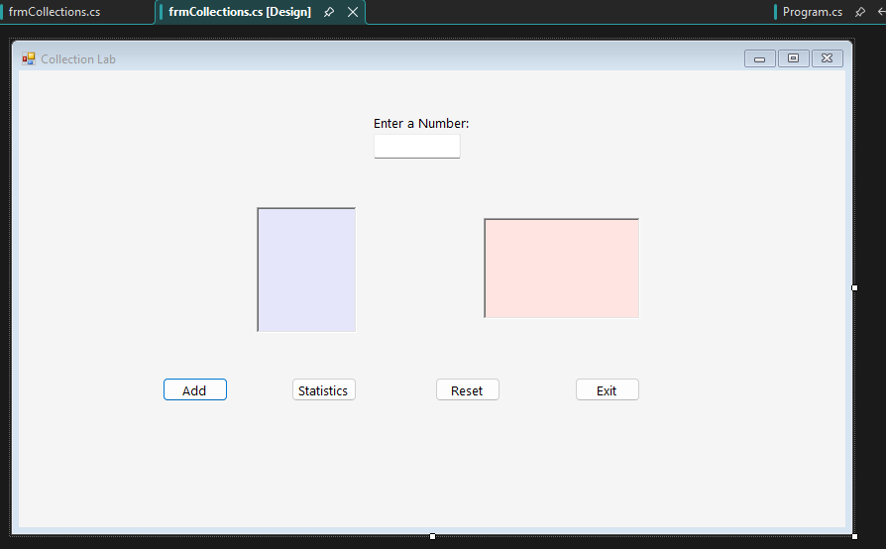

Screenshot 2:
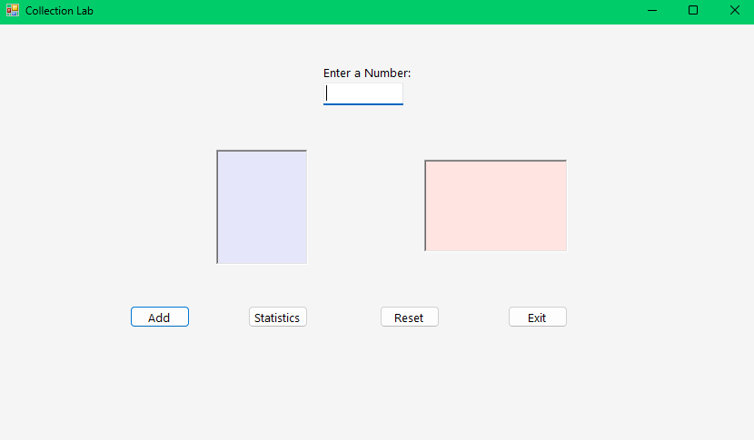

Screenshot 3: array of 9 numbers:
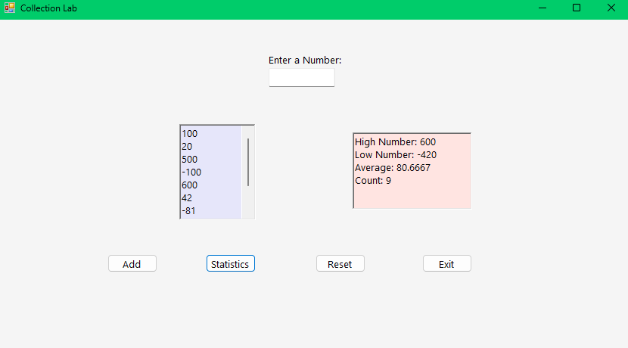

Screenshot 4 error message from word:
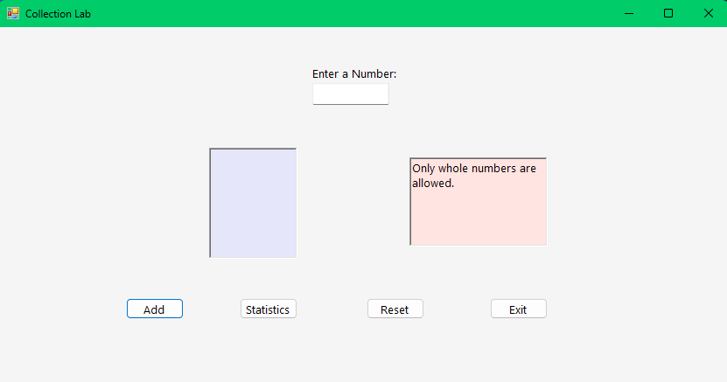
I entered Hello

Screenshot 5 error message when decimal input:
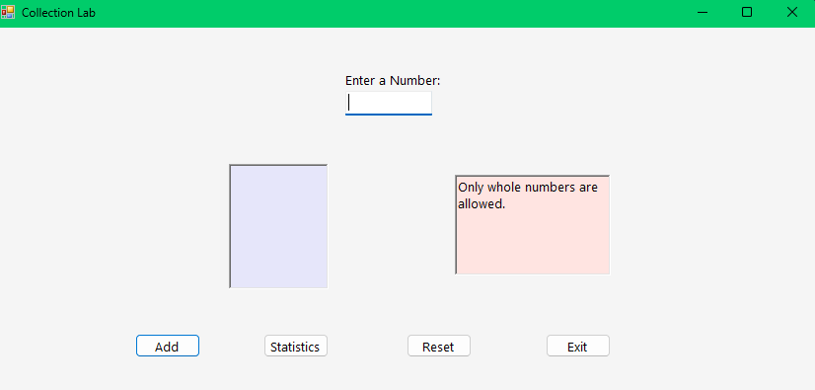
I entered 10.12

Screenshot 6 error message when number is too small: (-2000 entered)
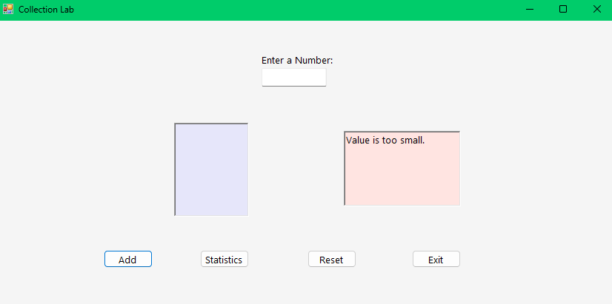

Screenshot 7 error when number is too big: (I put in 60,000)
